Carmine's Italian Deli and Cafe
7 Old Road, Elmsford, New York 10523
Tel: 914.345.2605
Carminescatering.com
THANKSGIVING DAY MENU

Store Hours: Thursday, November 26, 2026
10AM - 1PM
All Orders Must Be Picked Up By 1 PM
Orders Includes:
- Roasted Whole Fresh Turkey
- Stuffing
- Turkey Gravy
- Cranberry Sauce
Choices of Side Dishes:
- Green Bean Almandine
- Garlic Mashed Potatoes
- Roasted Vegetables w/ rose Mary
- Baked Sweet Potatoes
Choices of Pies:
- Apple Pie
- Pumpkin Pie
- Pecan Pie
- Coconut Custard
395.00 includes 18lb. Turkey, Gravy, Cranberry Sauce, Stuffing, 3 sides and 2 Pies
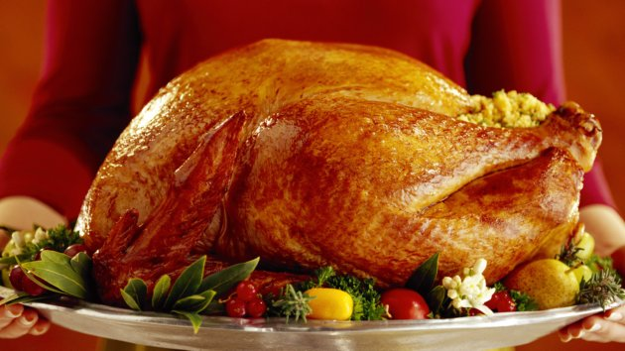
Check out My You tube Channel Robert Venuti to see how your Turkey is Prepared

